Data Visualisation Assignment 2

MATH2270 and MATH2237, Semester 2, 2017

# Visualising Open Data

**Due:** End of Week 9: 11:59 PM 24/9/2017 (10%)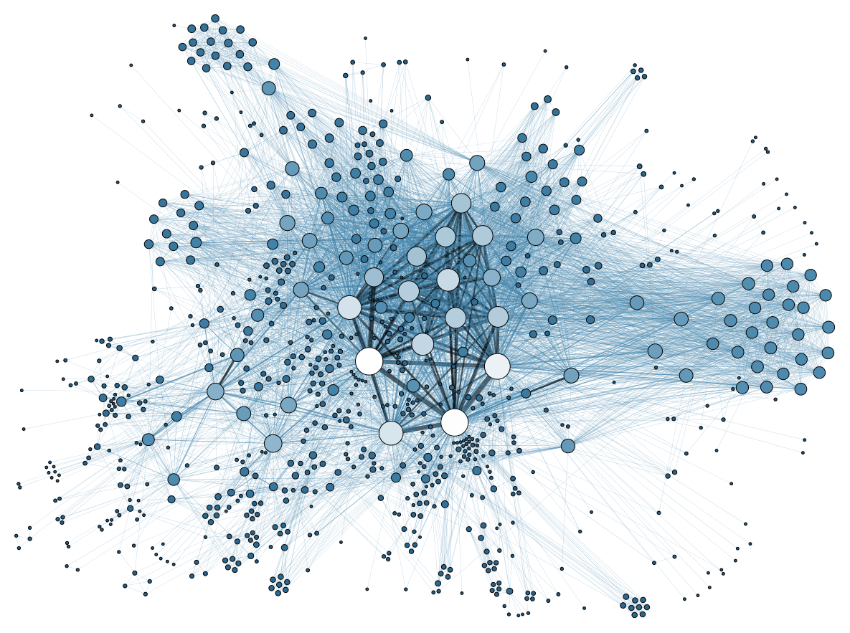

## Assignment Instructions

Assignment 2 is simple. I want you to demonstrate the full extent of your data visualisation capability that you have developed up to this point in the course. The choice of topic and data is yours. Choose something that will showcase your capability to your classmates, future employees, mum and the rest of the world. Do something meaningful, interesting and inspiring.

### Open Data

Assignment 2 is open-ended, but there will be one key requirement. The data to be used must be [open](https://en.wikipedia.org/wiki/Open_data) and ideally have a [Creative Commons Licence](http://creativecommons.org/). This will ensure you can share your work with the world provided you make proper attribution.

### Visualisation

* Work through Andy Kirk’s Visual Design Process described in [Module 1](https://dark-star-161610.appspot.com/secured/MATH2270_Module_01.html) in order to produce an insightful visualisation of the open data you selected.
* You can only submit one visualisation that must fit within a full HD screen (1920 × 1080). This can include faceted or multiple juxtaposed plots. As long as it fits within a HD screen, it will be permitted.
* This assignment will be about showcasing your data visualisation capabilities to the world. Therefore, your assignment submission must include a video/screencast of you presenting the data visualisation
* Each assignment must be accompanied by a descriptive caption (200 words max).
* Each visualisation must properly attribute the data source

## Video

* You will need to submit a Google Drive link to a video of you presenting your data visualisation. The video must play by clicking on the Google Drive link. **The video is limited to 3 minutes (max)**. The video must include at the very least an audio commentary of the topic and insight gained from the visualisation.
* For more information on creating video presentations, please see this website.

<https://sites.google.com/a/rmit.edu.au/m_analytics_video-presentations/>

## Submission Instructions

* Use the Assignment 2 [R Markdown template](https://drive.google.com/a/rmit.edu.au/file/d/0Bwtqn_QygJ8_VE9tZmN4MWtvQUk/view?usp=sharing)
* All visualisations must be submitted via the Turnitin link on the course Blackboard prior to the due date (code and visualisation).
* You must also submit the link to your video presentation in a separate assignment link (see Bb)
* The assignment must uploaded to Turnitin as a **PDF** with your visualisation and code chunks showing. The easiest way to achieve this is to **Preview** your notebook → **Open in Browser** (Chrome) → Right click on the report in Chrome → Click **Print** and Select the **Destination** Option to **Save as PDF**.

## Late Submissions

Late submissions will be marked in accordance with the late submission policy. Please see the [course information sheet](https://docs.google.com/a/rmit.edu.au/document/d/10GoxygcB12-I442pyepR1tkwhrMXcuIdoDSbBhyv9fg/edit?usp=sharing).

## Collaboration versus Collusion and Plagiarism

You are permitted to discuss and collaborate on the assignment with your classmates. **However, the assignment must be an individual effort.** Assignments will be submitted through Turnitin, so if you’ve copied code and data from a fellow classmate, it will be detected. It is your responsibility to ensure you do not copy or do not allow another classmate to copy your work. If plagiarism is detected, both the copier and the student copied from will be responsible. It is good practice to never share assignment files with other students. You should ensure you understand your responsibilities by reading the RMIT University website on [academic integrity](http://www1.rmit.edu.au/browse;ID=kkc202lwe1yv). Ignorance is no excuse.

## Marking Rubric

Please refer to Andy Kirk’s Visual Design Process described in [Module 1](https://dark-star-161610.appspot.com/secured/MATH2270_Module_01.html).

|  |  |  |  |  |
| --- | --- | --- | --- | --- |
| **Criteria** | **Not acceptable**  **(0)** | **Needs Improvement**  **(2)** | **Meets Expectation**  **(3)** | **Exemplar**  **(4)** |
| **Purpose**  **and Focus (20%)** | There was no apparent purpose to the data visualisation. The visualisation lacked an apparent focus. | The purpose of the data visualisation was not entirely clear. The focus of the visualisation could be improved by drawing better attention to key features or looking at the data from another angle. | The purpose of the data visualisation was clear. The focus of the visualisation drew attention to key features and provided insight, however, the focus could be narrowed or broadened to improve insight. | The purpose of the data visualisation was obvious. The focus of the data visualisation was very effective in conveying insight into the data. |
| **Options and Method**  **(20%)** | The visualisation demonstrated inappropriate choices in data representation, presentation and method. | The visualisation did not demonstrate the best choices in data representation, presentation and method. Better choices and methods could be used. | The visualisation demonstrated good choices in data representation, presentation and method. Only minor adjustments were needed or other alternate methods could be explored. | The visualisation demonstrated best practice in data representation, presentation and method. |
| **Insight**  **(20%)** | The visualisation did not demonstrate insight into the data. | The visualisation demonstrated some insight into the data. | The visualisation demonstrated a high degree of insight into the data. | The visualisation demonstrated original and important insight into the data. |
| **Objectives**  **(20%)** | The visualisation failed to meet the design objectives: Form vs. function, justification, accessibility and no deception. | The visualisation had some issues with the design objectives: Form vs. function, justification, accessibility and no deception. | The visualisation met most of the design objectives: Form vs. function, justification, accessibility and no deception. | Form and function were well balanced, decisions were justified, the design was intuitive and accessible, and did not deceive. |
| **Video (20%)** | No video/unacceptable video quality. | Video presentation was included, but there was room for improvement. | A good quality video presentation was included. Only minor improvements were needed. | A high quality video presentation was included. There was little that could be faulted. |